**Spacecraft Orbit Simulation**

***Project report submitted to*Indian Institute of Technology, Kharagpur  
for the partial fulfillment of the requirements  
for the award of the degree of**

**BACHELOR OF TECHNOLOGY**

**IN**

**AEROSPACE ENGINEERING**

**By**

**Soumy Ladha**

**(13AE3FP09)**

**Under the guidance of**

**Prof. Susmita Bhattacharyya**

**AEROSPACE ENGINEERING DEPARTMENT**

**INDIAN INSTITUTE OF TECHNOLOGY**

**KHARAGPUR -721302**



CERTIFICATE

This is to certify that the project report entitled **“Spacecraft orbit simulation”** submitted by **Soumy Ladha** (Roll No. 13AE3FP09) to Indian Institute of Technology Kharagpur towards fulfilment of requirements for the award of degree of Bachelor of Technology(Hons.) in Aerospace Engineering is a record of bonafide work carried out by him under my supervision and guidance during the academic session 2016-17.

Prof. **Susmita Bhattacharya**

Date: Assistant Professor

Place: Kharagpur Department of Aerospace Engineering

Indian Institute of Technology

ACKNOWLEDGEMENT

I would like to express my sincere gratitude to Prof. Susmita Bhattacharyya for providing me with this incredible opportunity to work under her esteemed guidance. I am incredibly grateful for her invaluable constructive criticism and friendly advice during the project work.

ABSTRACT

The objective of this project is to perform a realistic simulation of the motion of satellites orbiting the Earth. A realistic simulation of a satellite orbit around the Earth involves the simulation of its position, velocity, acceleration, and jerk (PVAJ) at different points of time in an Earth-centered coordinate frame. This provides a tool for validating algorithms to be used on board a satellite, which would require high fidelity simulations of satellite motion for validation purposes. In this semester, I simulated satellite PVAJ in the International Terrestrial Reference Frame (ITRF) from the orbital elements provided in International Celestial Reference Frame (ICRF). The work starts with the calculation of satellite PVAJ in ICRF from its orbital elements and then incorporates precession, nutation, rotation of Earth and polar motion to transform the calculated PVAJ in ICRF to ITRF. I validated the algorithms implemented in MATLAB by comparing the results with well-known published book results as well as using data available on the Internet.

Contents

**1** **INTRODUCTION** 6

**2** **BACKGROUND STUDY** 6

**2.1** **TIME** 6

**2.1.1** **Universal Time (UT1):** 7

**2.1.2** **Terrestrial Time (TT):** 7

**2.1.3** **International Atomic Time (TAI):** 7

**2.1.4** **Greenwich Mean Sidereal Time (GMST):** 7

**2.1.5** **Coordinated Universal Time (UTC):** 8

**2.1.6** **Julian Date:** 8

**2.2** **CELESTIAL AND REFERENCE SYSTEM** 8

**2.3** **PRECESSION** 9

**2.4** **NUTATION** 13

**2.5** **EARTH ROTATION AND POLAR MOTION** 15

**2.6** **TRANSFORMATION TO THE INTERNATIONAL REFERENCE POLE** 16

**3** **SIMULATION STUDIES** 16

**4** **CONCLUSION** 21

**5** **REFERENCES** 21

# **INTRODUCTION**

This project aims at developing a MATLAB-based tool for realistic simulation of various satellite orbits around the Earth. The simulation of such a satellite orbit involves the simulation of its position, velocity, acceleration, and jerk (PVAJ) at different points of time in an Earth-centered coordinate frame. This is particularly useful for validating algorithms that will be used onboard a satellite and require high fidelity simulation of satellite motion for validation purposes. An example includes advanced algorithms for a Global Positioning System receiver on board a low earth orbit satellite.

In the previous semester, I calculated satellite PVAJ over a period of time from the orbital elements provided in the International Terrestrial Reference Frame (ITRF) at the simulation start time. In this semester, I simulated satellite PVAJ in ITRF from the orbital elements provided in International Celestial Reference Frame (ICRF). The work begins with the calculation of satellite PVAJ in ICRF from its orbital elements and then incorporates precession, nutation, rotation of Earth and polar motion to transform the calculated PVAJ in ICRF to ITRF. For this purpose, the coordinate transformation matrix from ICRF to ITRF is calculated. To calculate velocity, acceleration, and jerk, the first, second and third derivatives of the coordinate transformation matrix are computed using the forward difference scheme. Using the transformed position in ITRF, I also calculated the geodetic latitude and longitude of the satellite. To validate results, I compared the outputs of my algorithms implemented in MATLAB with published book results and with the outputs of my previous semester’s code using GPS orbital elements available on the internet.

The organization of the report as follows: Section 2 describes the background study done. Then, Section 3 describes Simulation studies performed in this semester. Finally, Section 4 provides a conclusion.

# **BACKGROUND STUDY**

In this section, a brief description of all the concepts learned in this semester is provided. They include different time scales, reference systems, precession, nutation, Earth rotation and polar motion. Each of them is described next.

The definition of both time and the fundamental reference systems has been defined by the rotational and translational motion of the Earth. It has now advanced to ideally uniform atomic time scales and a preferably non-rotating celestial reference frame.

## **TIME**

We measure time in days of 86400 seconds duration, where we determine the length of the solar day from subsequent meridian transits of the Sun. Because of the orbital motion of the Earth around the Sun, the Sun’s right ascension changes by approximately one degree per day and the solar day is thus about 4 minutes longer than the period of the Earth’s rotation, which is also known as sidereal day which amounts to 23h56m4s.

In modeling of Earth orbiting satellites we use the following time scales:

### **Universal Time (UT1):**

Universal Time UT1 is the presently adopted realization of a mean solar time scale with the purpose of achieving a constant average length of the solar day of 24 hours. As a result, the duration of one second of Universal Time is not constant, because the actual mean length of a day depends on the rotation of the Earth and the apparent motion of the Sun (i.e. the length of the year). It is not possible to determine Universal Time by a direct conversion. Every change in the Earth’s rotation alters the length of the day, and must, therefore taken into account in UT1. Universal Time is a function of sidereal time, which directly reflects the rotation of the Earth.

|  |  |  |
| --- | --- | --- |
|  |  | ( 1) |

|  |  |  |
| --- | --- | --- |
|  |  | (2) |
|  |  | (3) |
|  |  | (4) |

Equation (1-2) as derived by [1]

### **Terrestrial Time (TT):**

A conceptually uniform time scale that will be measured by an ideal clock on the surface of the geoid. TT is measured in days of 86400 SI. The difference between Universal Time and Terrestrial Time or International Atomic Time can only be determined retrospectively. At the end of the 20th-century ΔT = TT−UT1 amounts to roughly 65 s and increases by about 0.5 to 1.0 seconds per year.

### **International Atomic Time (TAI):**

Which provides the practical realization of a uniform time scale based on atomic clocks and agrees with TT except for a constant offset of 32.184 s.

### **Greenwich Mean Sidereal Time (GMST):**

Also known as Greenwich Hour Angle, denotes the angle between the mean vernal equinox of date and the Greenwich meridian. It is a direct measure of the Earth’s rotation and jointly expressed in angular units or units of time with 360◦ (2π) corresponding to 24h. The length of a sidereal day (i.e. the Earth’s spin period) amounts to 23h56m4s .091 ± 0.005, making it about four minutes shorter than a 24h solar day. Due to length-of-day variations with an amplitude of several milliseconds, sidereal time cannot be computed from other time scales with sufficient precision but must be derived from astronomical and geodetic observations.

### **Coordinated Universal Time (UTC):**

It is tied to the International Atomic Time TAI by an offset of integer seconds that is regularly updated to keep UTC in close agreement with UT1. Clock time is derived from Coordinated Universal Time (UTC). Since 1972, UTC is obtained from atomic clocks running at the same rate as International Atomic Time and Terrestrial Time. By the use of leap seconds, which may be inserted at the end of June and the end of December, care is taken to ensure that UTC never deviates by more than 0.9 seconds from Universal Time UT.

### **Julian Date:**

Julian day is the continuous count of days since the beginning of the Julian Period. The Julian Day Number (JDN) is the integer assigned to a whole solar day in the Julian day count starting from noon [Universal time](https://en.wikipedia.org/wiki/Universal_time), with Julian day number 0 assigned to the day starting at noon on January 1, [4713 BC](https://en.wikipedia.org/wiki/4713_BC). The Julian date (JD) of any instant is the Julian day number for the preceding noon in Universal Time plus the fraction of the day since that instant. Julian dates are expressed as a Julian day number with a decimal fraction added.

## **CELESTIAL AND REFERENCE SYSTEM**

The equation of motion as derived describes the orbit of a satellite on a Newtonian reference system, i.e. on a coordinate system that moves with the center of the Earth but is free of rotation. Satellite observations, on the other hand, are commonly obtained from an observing site on the surface of the Earth, which is not at rest in this reference system. To compare ground-based measurements with the computed satellite position, a definition of celestial and terrestrial reference systems is required, and their mutual relation has to be established. While the orbital plane of a body around a central mass is fixed in space as long as the attractive force is parallel to the radius vector, this condition does not hold for the Earth due to the presence of other solar system planets. This results in a variation of the orbital plane which is known as planetary precession. At the same time, the Earth’s axis of rotation is perturbed by the torque exerted on the equatorial bulge by the Sun and Moon. This torque tries to align the equator with the ecliptic and results in a gyroscopic motion of the Earth’s rotation axis around the pole of the ecliptic with a period of about 26000 years. As a consequence of this lunisolar precession, the vernal equinox recedes slowly on the ecliptic, whereas the obliquity of the ecliptic remains essentially constant. In addition to precession, some minor periodic perturbations of the Earth’s rotation axis may be observed that are known as nutation. Given the time-dependent orientation of equator, a standard reference frame is usually based on the mean equator, ecliptic, and equinox of some fixed epoch, which is currently selected as the beginning of the year 2000.

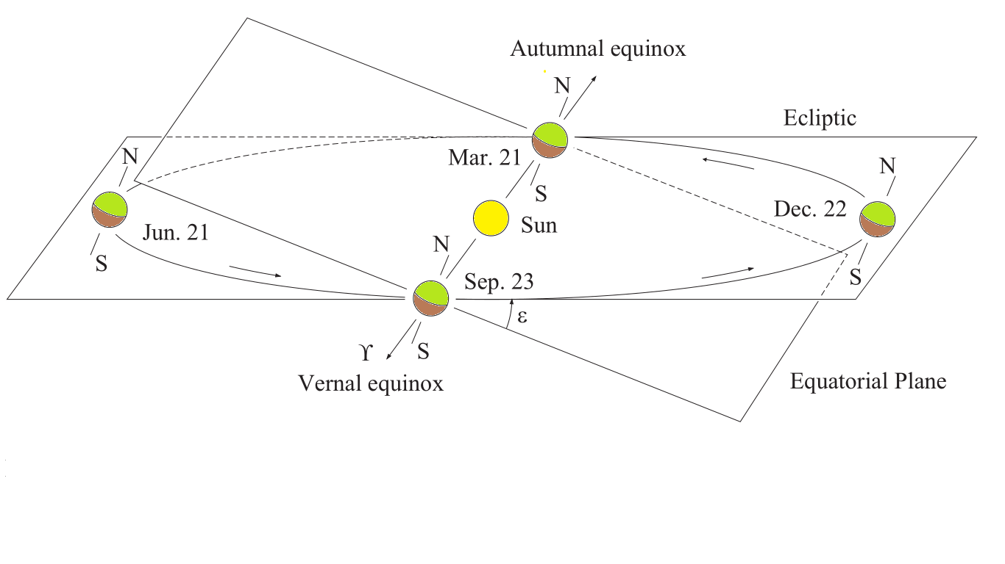

Figure 1: Ecliptic Plane and Equatorial Plane

The origin of the ICRS is defined as the solar-system barycenter, and its axes are fixed with respect to distant extragalactic radio objects. These have no proper motion, thus ensuring that the ICRS exhibits no net rotation. Complementary to the ICRS, the International Terrestrial Reference System (ITRS) provides the conceptual definition of an Earth-fixed reference system. Its origin is located at the Earth’s center of mass, and its unit of length is the SI meter.

Conventional models for accomplishing the transformation between the International Celestial Reference System and the International Terrestrial Reference System are:

* Precession is describing the secular change in the orientation of the Earth’s rotation axis and the equinox.
* Nutation is describing the periodic and short-term variation of the equator and the vernal equinox.
* Sidereal Time in relation to UT1 describing the Earth’s rotation about its axis.

## **PRECESSION**

The earth is considered a rotationally symmetric gyroscope with an angular momentum *l* that change due external torque ***D*** according

|  |  |  |
| --- | --- | --- |
|  |  | (5) |

|  |  |
| --- | --- |

The direction of the angular momentum may differ from the symmetry axis of a gyroscope and the instantaneous axis of rotation. Due to the earth’s flatting and its internal structure, the actual moments of inertia are given by

|  |  |  |
| --- | --- | --- |
|  |  | (6) |

The torque is given by

|  |  |  |
| --- | --- | --- |
|  |  | (7) |

|  |  |
| --- | --- |

|  |  |  |
| --- | --- | --- |
|  |  | (8) |

|  |  |
| --- | --- |

The sun moves around the earth in a near-circular orbit that is inclined at an angle e on the equator, and the resulting torque vanishes whenever the Sun crosses equator (z = 0). Which results in a mean solar torque

|  |  |  |
| --- | --- | --- |
|  |  | (9) |

|  |  |
| --- | --- |

In the direction of the vernal equinox during the year. The earth experiences the similar torque due to moon adding torque due to both of sun and moon results in the mean torque of

|  |  |  |
| --- | --- | --- |
|  |  | (10) |

Equation (7-10) as derived by [1]

|  |  |
| --- | --- |

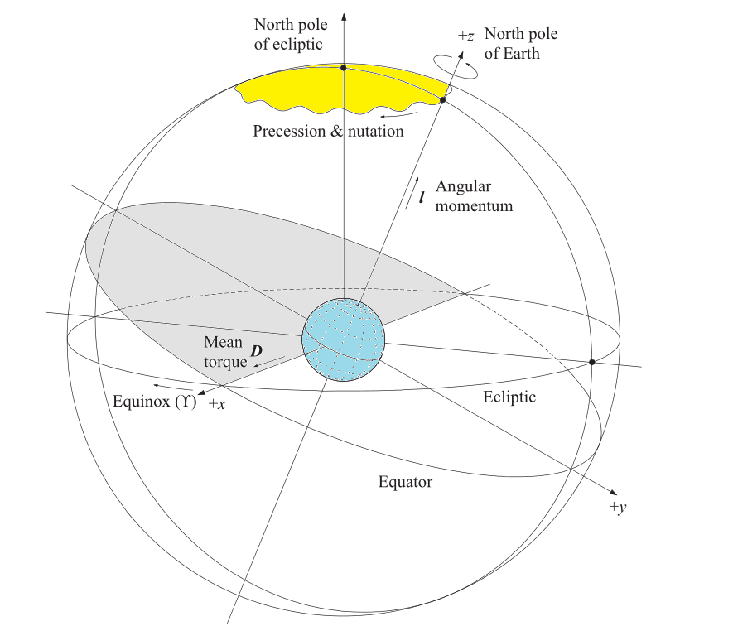

Figure 2: Motion of the Earth’s axis under the influence of solar and lunar torques

The combined effects of precession on the orientation of the ecliptic and the equatorial plane causes a change in the coordinate. Due to lunisolar precession the intersection of the mean equator of epoch (t) and the mean ecliptic of J2000 lags behind the vernal equinox. The three angles define the orientation of the mean equator and equinox of epoch T on the equator and equinox of J2000.Depending on the epoch one can precess from one epoch to another epoch. In this the epoch considered is J2000 (JED 2451545.0).

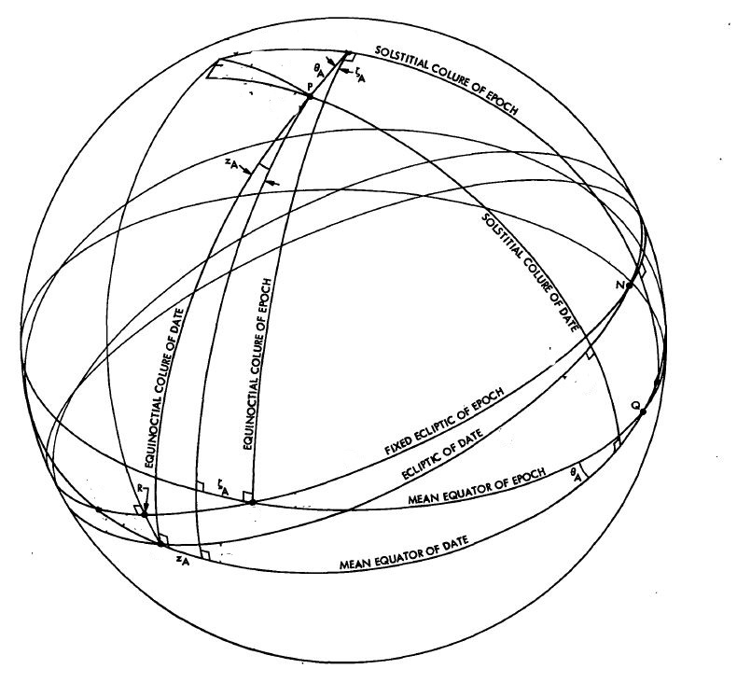

Figure 3: The effects of precession on the ecliptic, equator, and vernal equinox

|  |  |  |
| --- | --- | --- |
|  |  | (11) |

|  |  |  |
| --- | --- | --- |
|  |  | (12) |

|  |  |
| --- | --- |

Where

|  |  |  |
| --- | --- | --- |
|  |  | (13) |

Equation (11-13) as derived by [2]

|  |  |
| --- | --- |

## **NUTATION**

Aside from the secular precessional motion, the orientation of the Earth’s rotation axis is affected by small periodic perturbations that are known as nutation. They are due to the monthly and annual variations of the lunar and solar torque that have been averaged in the treatment of precession. The main contribution to nutation is from the different orientation of the lunar orbit on the Earth’s equator as expressed by the longitude of the Moon’s ascending node Ω. It induces a cyclic shift.

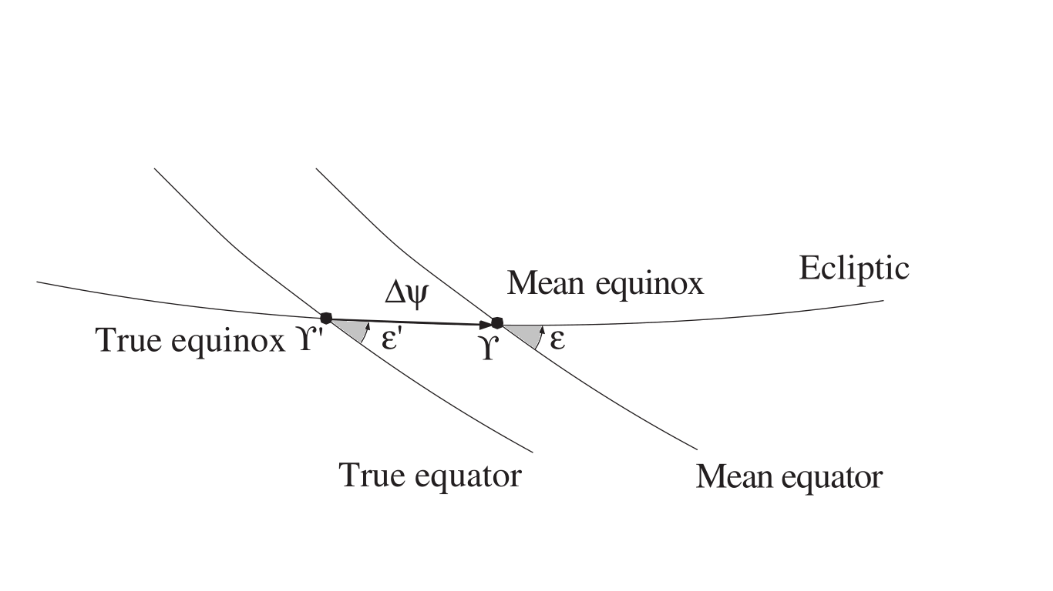

Figure 4: The change in the positions of the equator, the ecliptic and the vernal equinox caused by nutation

|  |  |  |
| --- | --- | --- |
|  |  | (14) |

Of the vernal equinox and change.

|  |  |  |
| --- | --- | --- |
|  |  | (15) |

Of the obliquity of the ecliptic during the 18.6-year nodal period of the Moon. As a result, the true celestial pole performs an elliptic motion around the mean position as affected by the lunisolar precession. The currently adopted IAU 1980 expresses the nutation angles.

|  |  |  |
| --- | --- | --- |
|  |  | (16) |

|  |  |  |
| --- | --- | --- |
|  |  | (17) |

By a total of 106 terms. Each term describes a periodic function of the mean elements of the lunar and solar orbit with argument

|  |  |  |
| --- | --- | --- |
|  |  | (18) |

The other parameters are:

* Moon’s mean anomaly (l)
* The Sun’s mean anomaly (l’ )
* the average distance of the Moon from the ascending node (F)
* The difference between the mean longitudes of the Sun and the Moon (D)
* the average longitude of the ascending node of the lunar orbit (Ω)

Numerical values for use with the IAU 1980 theory of nutation are originally given as:

|  |  |  |
| --- | --- | --- |
|  |  | ( 19) |

|  |  |  |
| --- | --- | --- |
|  |  | (20) |

Equation (14-20) as derived by [1]

## **EARTH ROTATION AND POLAR MOTION**

The IAU precession and nutation theories give the instantaneous orientation of the Earth’s rotation axis, or, the orientation of the Celestial Ephemeris Pole (CEP) with respect to the International Celestial Reference System. The rotation about the CEP axis itself is described by the Greenwich Mean Sidereal Time (GMST) that measures the angle between the mean vernal equinox and the Greenwich Meridian. Given the UT1–UTC or UT1–TAI time difference as monitored by the IERS, the Greenwich Mean Sidereal Time at any instant can be computed from the conventional relation. Similar to GMST, the Greenwich Apparent Sidereal Time (GAST) measures the hour angle of the true equinox. Both values differ by the nutation in right ascension, which is also known as the equation of the equinoxes. Given the apparent sidereal time, the matrix Yields the transformation between the true-of-date coordinate system and a system aligned with the Earth equator and Greenwich meridian.

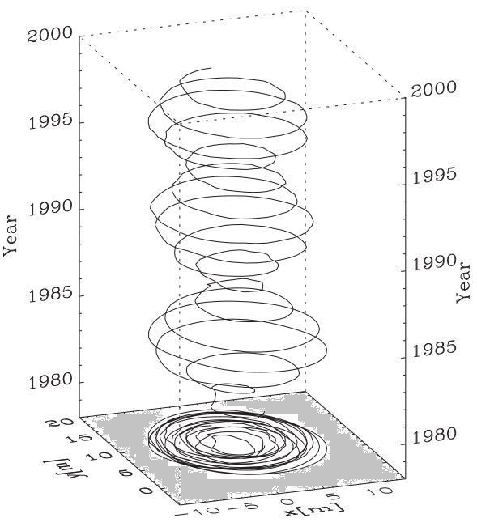

Figure 5: Polar Motion

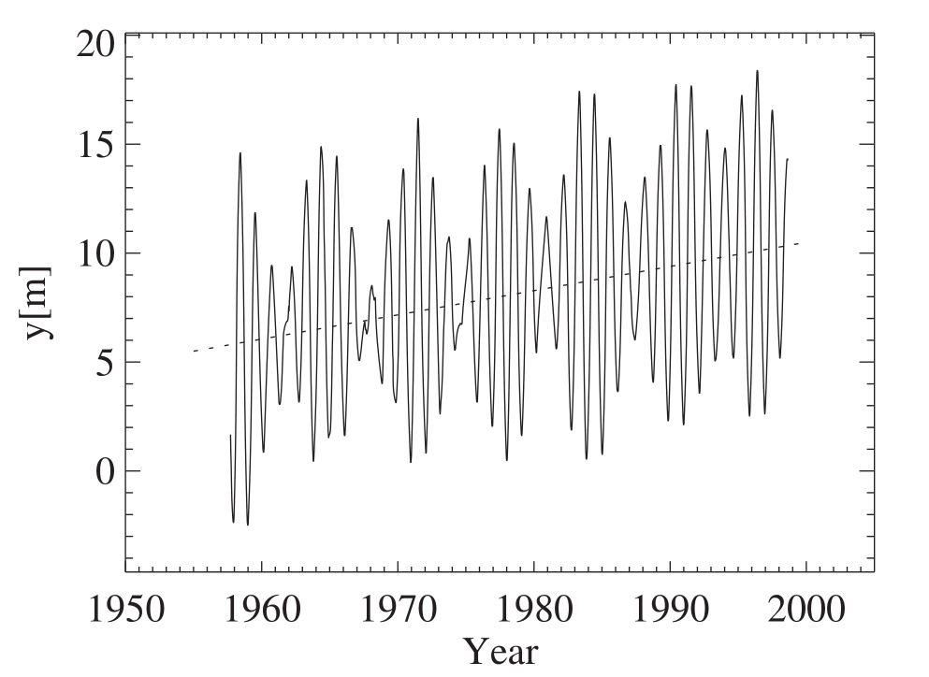

Figure 6: Y vs. Year

A non-rigid Earth model can only explain the expected 305 day period of the polar motion. The second part is an annual motion that is induced by seasonal changes of the Earth’s mass distribution due to air and water flows. In contrast to precession and nutation motion of the rotation axis on the surface of the Earth cannot, therefore, be predicted from theory but has to be monitored by continuous observations. For this purpose, the mean position of the pole of rotation during the years 1900 to 1905 is usually chosen as the origin for polar motion measurements.

## **TRANSFORMATION TO THE INTERNATIONAL REFERENCE POLE**

The conversion from true-of-date coordinates to the International Terrestrial Reference System may be expressed as

|  |  |  |
| --- | --- | --- |
|  |  | (21) |

# **SIMULATION STUDIES**

The PVAJ of an Earth-orbiting satellite are first calculated in the ICRF. Then the calculated PVAJ are transformed to ITRF using the coordinate transformation matrix and its derivatives. The coordinate transformation matrix is calculated considering precession, nutation, Earth rotation and polar motion, as discussed before. The matrix derivatives are calculated numerically using the forward difference scheme. Flowcharts of all the algorithms implemented are developed. Programs are written in MATLAB following industry coding standards. A graphical editor is also created in MATLAB for the user to enter the orbital elements and other relevant input parameters.

The Validation of the written code is done in the following ways: First, the computed coordinate transformation matrix and its first order derivative are matched to the results provided in [1] for the orbital elements of a satellite in ICRF (see Figures 7 – 10). Then, using the code written in the previous semester, PVAJ of three different GPS satellites are simulated using their orbital elements available on an authentic website. From the PVAJ plots of these satellites (Figures 11 – 13), some signatures common to all the three satellites are identified. They are position and velocity time periods in ITRF, magnitudes of the satellite velocity, acceleration and jerk, and overall temporal variations of PVAJ. Next, the PVAJ of a GPS satellite are calculated using the MATLAB code developed in this semester and using the orbital elements of the satellite in ICRF obtained from [1]. In the plots of the calculated PVAJ (Figure 14), signatures identified in the other three satellites’ plots are noted, which partially validates the correctness of the results obtained in this semester.

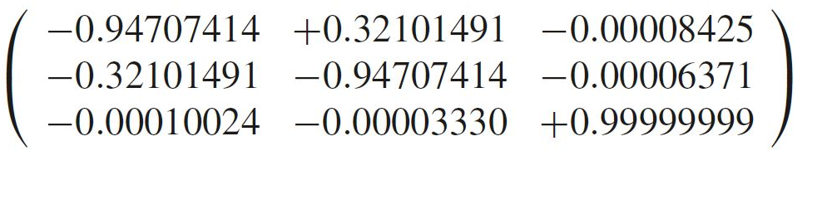

Figure 7 Coordinate Transformation Matrix as in [1]

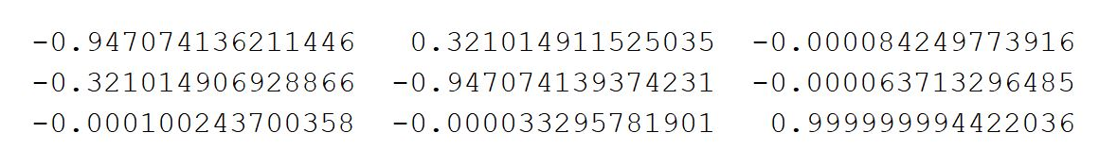

Figure 8 Coordinate transformation matrix using Code

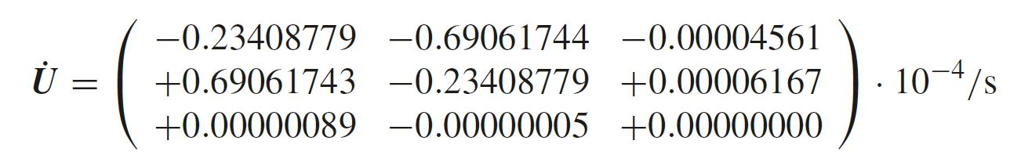

Figure 9 Coordinate matrix derivative as given in [1]

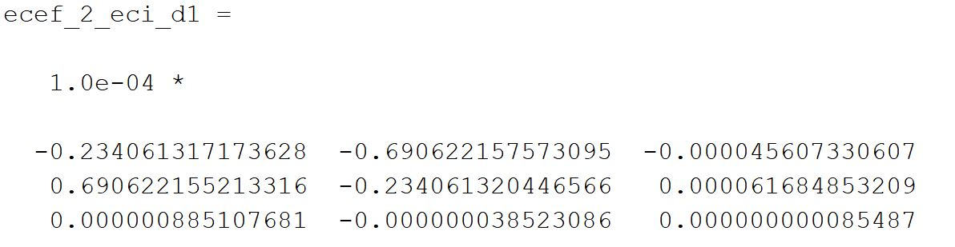

Figure 10 Coordinate Matrix derivative calculated numerically using code

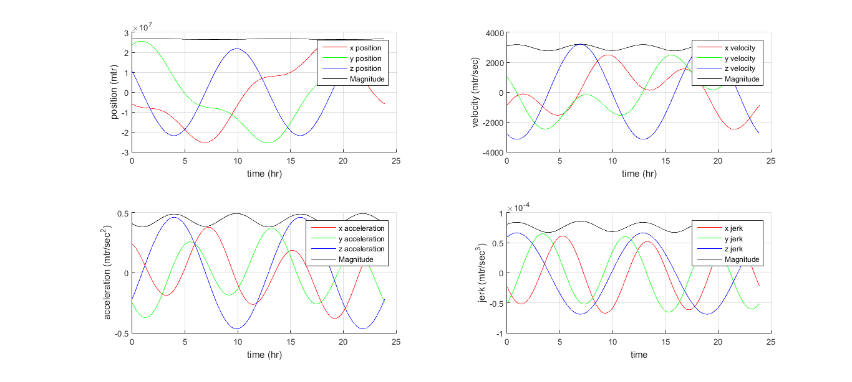

Figure 11 Simulation of satellite motion using orbital parameters in ITRF (GPS satellite 1)

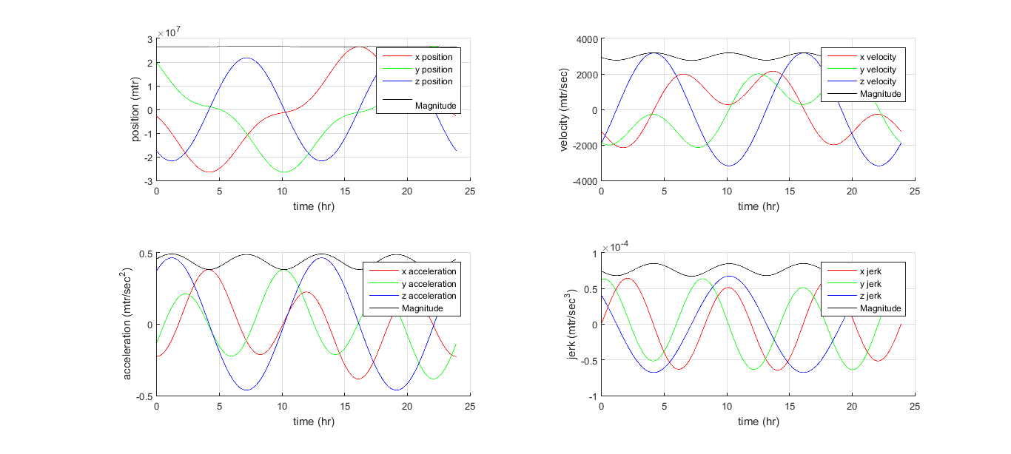

Figure 12 Simulation of satellite motion using orbital parameters in ITRF (GPS Satellite 2)

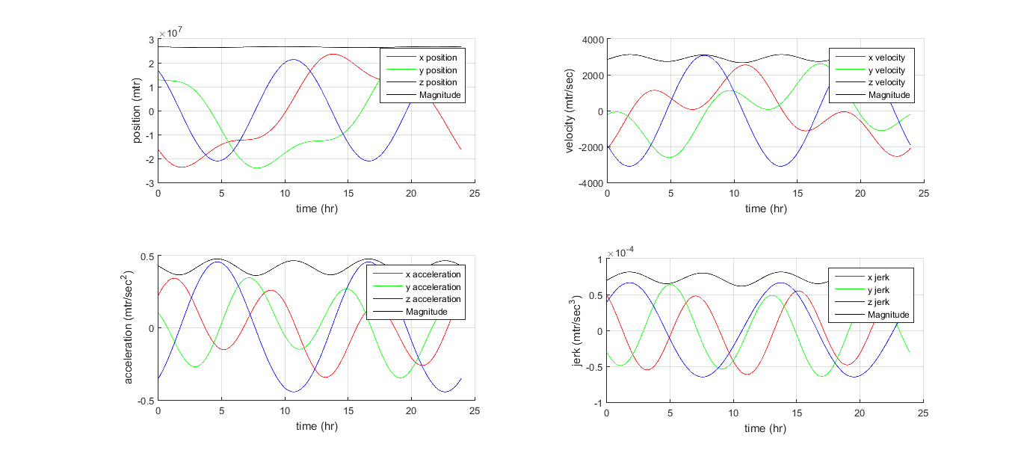

Figure 13 Simulation of satellite motion using orbital parameters in ITRF (GPS Satellite 3)

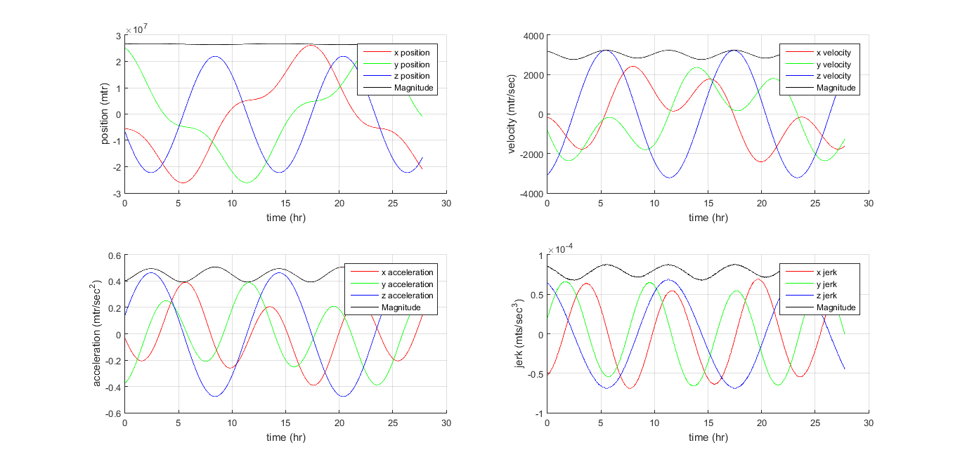

*Figure 14 Simulation of a GPS Satellite motion from orbital parameters in ICRF obtained from [1]*

# **CONCLUSION**

In this project, a MATLAB-based tool for simulating the motion of an Earth-orbiting satellite is developed. The tool can accept satellite orbital elements either in ITRF at the start of the simulation time or in ICRF and calculates satellite PVAJ in ITRF over a period of time at a specified time step, as defined by the user. The work included a literature survey during which all necessary concepts for satellite motion simulation (e.g., time scales, reference systems, precession, nutation, etc.) are learned. Following this, the algorithms are implemented in MATLAB using industry coding standards. Simulation results are plotted and compared with available data. Future work will simulate perturbations to satellite orbits to make the simulation more realistic.

# **REFERENCES**

1. Oliver Montenbruck • Eberhard Gil.; *Satellite Orbits Models, Methods, and Applications*; Springer-Verlag Berlin Heidelberg (2000).
2. Jay H. Lieske; *Precession Matrix Based on IAU (1976) System of Astronomical Constants;* Astronomy and Astrophysics, vol. 73, no. 3, Mar. 1979.